**“Artificial Intelligence Blockchain Based Fake News Discrimination”**

***An Industrial Oriented major project report submitted to JNTUH in the partial fulfillment of the requirements for the award of the degree of***

**Bachelor of Technology**

**In**

**Computer Science & Engineering**

**Submitted By**

**Batch No. - 01**

**SHAIK SUMAYA - 21631A0554**

**MOHAMMED FARAAZ - 21631A0520**

**TELAPUTTA RAJU - 21631A0539**

**VEESALA PAVAN - 21631A0535**

**DARA VARSHITHA - 21631A0563**

***Under the Esteemed guidance of***

***Mr. P. RATHAIAH, M.Tech***

**Sr. Assistant Professor in CSE Dept**



**DEPARTMENT OF COMPUTER SCIENCE AND ENGINEERING**

**SRI VENKATESWARA ENGINEERING COLLEGE**

(SPONSORED BY THE EXHIBITION SOCIETY, HYDERABAD)

(Affiliated to Jawaharlal Nehru Technological University, Hyderabad)

(Approved by AICTE, NEW DELHI)

SURYAPET – 508213 JUNE-2025.

# DEPARTMENT OF COMPUTER SCIENCE AND ENGINEERING

# SRI VENKATESWARA ENGINEERING COLLEGE SURYAPET-508213



# CERTIFICATE

This is to certify that the project report entitled “**Artificial Intelligence Blockchain Based Fake News Discrimination**” is the bonafide work done by **SK. SUMAYA (21631A0554), MD. FARAAZ (21631A0520), T. RAJU (21631A0539), V. PAVAN (21631A0535), D. VARSHITHA (21631A0563)** in partial fulfilment of the requirements for the award of **BACHELOR OF TECHNOLOGY** in **Computer Science and Engineering** by JNTUH during the academic year 2025.

**Guide Head of the Department**

**Mr. P. RATHAIAH,** M. Tech (CSE) **Mr. P. RATHAIAH,** M. Tech (CSE)

Sr. Assistant Professor Sr. Assistant Professor

Sri Venkateswara Engineering College, Sri Venkateswara Engineering College,

Suryapet. Suryapet.

**Principal External Examiner**

**Dr. RAJU MUTHYALA**, M Tech, Ph. D,

Sri Venkateswara Engineering College, Suryapet.

## DECLARATION

To the best of our knowledge and belief, we hereby declare that this project bears no resemblance to any other project submitted at Sri Venkateswara Engineering College, Suryapet or any other college. We, SHAIK SUMAYA, MOHAMMED FARAAZ, TELAPUTTA RAJU, VEESALA PAVAN, DARA VARSHITHA, students of B. Tech with CSE of Sri Venkateswara Engineering College, Suryapet, being H.T. No 21631A0554, 21631A0520, 21631A0539,21631A0535 and 21631A0563 respectively hereby declare that the project with title “**Artificial Intelligence Blockchain Based Fake News Discrimination**” is the original work done by us. Affiliated to Jawaharlal Nehru Technological University, Hyderabad for the award of the degree.

**Signature of the candidate**

* SHAIK SUMAYA,
* MOHAMMED FARAAZ,
* TELAPUTTA RAJU,
* VEESALA PAVAN,
* DARA VARSHITHA.



**ACKNOWLEDGEMENT**

We thank the almighty for giving us the courage and perseverance in complete the project. This project itself is an acknowledgment for all those people who have given this project a success.

We take this opportunity to express our deep and sincere gratitude to the project guide **Mr. P.RATHAIAH SIR**, Assistant Professor for his valuable advice at every stage of this work. Without his supervision and valuable guidance, I never have come out in this form.

We are also thankful to **Mr. P. RATHAIAH SIR** Head of the department of computer science and engineering, and, **Dr. M. RAJU** Principal, for providing excellent facilities, motivation, and encouragement to complete the project work on time.

Last but not least we would like to express our deep sense of gratitude and earnest thanks giving to our parents for their moral support and heartfelt cooperation in doing the project. We would also like to thank all the teaching and non-teaching staff and my friends whose direct or indirect help has enabled us to complete this work successfully.

**Project Associate**

**SK.SUMAYA -21631A0554**

**MD.FARAAZ -21631A0520**

**T.RAJU -21631A0539**

**V.PAVAN -21631A0535**

**D.VARSHITHA -21631A0563**

**ABSTRACT**

The project aims to minimize the impact of fake news by leveraging blockchain and artificial intelligence technologies, while also verifying the authenticity of news through a secure and tamper-proof storage solution. By utilizing blockchain technology, the project ensures data integrity and provides a reliable platform for storing news articles, making it difficult for malicious actors to manipulate information. The focus is on employing various AI algorithms, including Artificial Neural Networks (ANN), Case-Based Reasoning (CBR), and Long Short-Term Memory (LSTM) networks, to predict the future spread of fake news. This approach enhances the understanding of how misinformation propagates and enables timely interventions. Smart contracts, designed using Solidity programming, facilitate the secure storage and retrieval of news data on the blockchain, further enhancing the system's reliability. Additionally, advanced AI techniques such as Bi-directional Gated Recurrent Units (GRU) and XGBoost are incorporated to improve the accuracy of fake news detection. Collectively, these innovations contribute to a more trustworthy information ecosystem, empowering users to discern credible news from misinformation effectively.

**TABLE OF CONTENTS**

|  |  |  |
| --- | --- | --- |
| S.NO | CONTENT | PGNO |
| 1 | Introduction   * 1. Objective   2. Problem Statement   3. Software requirements   4. Hardware requirements | 1 |
| 2 | Feasibility study | 4 |
| 3 | Literature survey | 5 |
| 4 | System analysis  4.1 Existing system  4.1.1 Disadvantages of existing system  4.2 Proposed system  4.2.1 Advantages of proposed system  4.3 Functional requirements  4.4 Non-Functional requirements | 8 |
| 5 | System design  5.1 System architecture  5.2 UML diagrams | 11 |
| 6 | Implementation  6.1 Modules  6.2 Sample code | 23 |
| 7 | Software environment | 33 |
| 8 | System testing  8.1 Testing strategies  8.2 Test cases | 40 |
| 9 | Screenshots | 43 |
| 10 | Conclusion | 53 |
| 11 | References | 54 |

**LIST OF FIGURES**

|  |  |  |
| --- | --- | --- |
| FIG.NO | FIG.NAME | PG.NO |
| 5.1.1 | System architecture | 11 |
| 5.1.2 | Data Flow Diagram - Publisher | 13 |
| 5.1.3 | Data flow diagram - Subscriber | 14 |
| 5.2.1 | Use case diagram | 16 |
| 5.2.2 | Class diagram | 17 |
| 5.2.3 | Activity diagram | 18 |
| 5.2.4 | Sequence diagram | 19 |
| 5.2.5 | Collaboration diagram | 20 |
| 5.2.6 | Component diagram | 21 |
| 5.2.7 | Deployment diagram | 22 |

**CHAPTER 1. INTRODUCTION**

In this paper, fake news can be defined as false information produced and distributed to cause a misunderstanding of facts. Fake news causes serious economic and social damage, and according to the Hyundai Economic Research Institute, the social cost incurred by fake news is estimated to be 30 trillion won per year. Fake news is spreading in a way that maliciously edits existing articles or impersonates media companies. As a result, studies are being conducted at home and abroad to detect fake news. Among overseas studies, there is a study called Bitpress that distinguishes fake news as a weight for a citation using Ethereum, a public Blockchain, but due to the nature of the public Blockchain, compensation, partial branching, and processing according to nodes is created. There is a problem of solving problems, such as speed and journalism is essentially an act of pursuing ‘Truth’. News content [1], the result of journalism, has different characteristics from any other content. Above all this is the performance of public duties. Therefore, it is common for ‘Reporters’ to take charge of the production of news content [2]. Today, we stand in the middle of the Clichane era with the term ‘Crisis of journalism’. Oxford Dictionary selected ‘Exhaustion Room’ as the word of the word in 2016. It is diagnosed that exhaustion is not a local phenomenon, but a characteristic of the era that appears worldwide. As if to prove this diagnosis, ‘Fake News’ emerged as a global controversy around the time of the U.S. presidential [3]. The fake news problem is still being solved. It is prevalent online and offline, remaining as homework that has not been done. The reason why journalism is facing a crisis is multi-layered. And at the center of it lies a huge monopoly. In other words, there are large media structures that erode diversity and monopolize public opinion, and large IT platform operators that monopolize the distribution and profits of content, such as portals and Social Network Services (SNS). It is very important to verify fake news of journalism in crisis with Blockchain technology. Blockchain is often referred to as a ‘technology of trust’. In other words, it is a system that trades between individuals participating in the network without a third party acting as a middleman, then verifies and records the information together. Until the advent of Blockchain technology [4], we did not find a way to trust the counterparty when dealing with someone on an online network.

* 1. **OBJECTIVE**

This paper aims to develop a secure and efficient system to combat fake news by integrating Blockchain technology with advanced Artificial Intelligence (AI) algorithms. The objectives are to ensure data integrity and tamper-proof storage of news articles using a private Blockchain, and to accurately predict the authenticity of news content through AI models like ANN, LSTM, Bi-directional GRU, and XGBOOST. Additionally, the system seeks to enhance scalability and performance through Blockchain’s parallel processing capabilities and smart contracts for secure data management.

* 1. **PROBLEM STATEMENT**

The proposed project for fake news detection presents a comprehensive framework that integrates Blockchain technology for secure news storage and Artificial Intelligence algorithms for accurate detection. It addresses the issue of fake news dissemination caused by the ease of tampering in centralized systems. The system includes processes such as dataset handling, news content analysis, and AI-based classification to identify fake news. By combining ANN, LSTM, and GRU models with Blockchain’s immutability, the project ensures authenticity and integrity of news articles. It also highlights the social impact of misinformation and aims to restore trust in digital media. The effectiveness of the model is evaluated using standard performance metrics and real-time scenarios.

* 1. **SOFTWARE REQUIREMENTS**

**Software Requirements**

* Python IDLE ( 3.7.0)
* Node Js
* Visual Studio Community Version
* Ganache
* MetaMask - Chrome Extension

**Back-end Languages**

* Python
* Java Script
* Solidity

**FrameWork**

* Django

**Front-end Languages**

* HTML
* CSS
* JS
* Bootstrap4

**1.4 HARDWARE REQUIREMENTS**

* **Operating System : Windows Only**
* **Processor : i5 and above**
* **Ram : 8GB and above**
* **Hard Disk : 20 GB in local drive**

**CHAPTER 2. FEASIBILITY STUDY**

A Feasibility Study in Project Management is a comprehensive analysis conducted to determine the practicality and viability of a proposed project. It assesses various aspects such as technical, economic, legal, operational, and scheduling feasibility to ascertain if the project can be successfully completed within defined constraints. The study helps stakeholders make informed decisions about whether to proceed with the project or explore alternative options based on the identified risks, costs, benefits, and potential outcomes.

**Types of Feasibility Study**

**Technical Feasibility Study:**

This type of feasibility take a look at evaluating a project’s technical capabilities, consisting of the accessibility of the resources, technology, and knowledge had to deliver it out efficiently. It assesses whether or not the project may be technically finished on time.

**Economic Feasibility Study:**

Economic feasibility studies examine a project’s expenses and feasible benefits to determine whether or not it’s financially viable. This entails comparing the project’s effect on income, charges, and profitability as well as doing cost-benefit analysis and calculating return on funding (ROI)..

**Social Feasibility Study:**

It evaluates how a task will have an effect on stakeholders, neighborhood communities, and society as a whole on a social and cultural stage. To decide if the project is socially possible and suitable, they determine variables like social acceptance, stakeholder participation, community effect, and company social responsibility.

# CHAPTER 3. LITERATURE SURVEY

**3.1 S-HAN: Hierarchical Attention Networks with Stacked Gated Recurrent Unit for Fake News Detection:**

<https://ieeexplore.ieee.org/document/9197914>

**ABSTRACT:** Social Media has become an inseparable part of our daily lives. With the boon that it is, it also brings along with itself the biggest menace i.e. fake news. Encountering fake news while accessing social media has become a recurrent phenomenon nowadays. This problem is grabbing attention all over the world as it is becoming a threat to the society. It is leading to violence all over the world. We aim to create a model S-HAN to identify the fake news. Our model uses an improved version of Hierarchical Attention Networks using stacked bidirectional Gated Recurrent Units (GRU) to identify the important words and sentences in the news which assists in the identification of misinformation. We have obtained better results compared to the standard baseline models of deep learning. We have obtained an accuracy of 93.63% for our model on a real-world dataset.

**3.2 Fake News Detection:**

<https://ieeexplore.ieee.org/document/8546944>

**ABSTRACT:** Information preciseness on Internet, especially on social media, is an increasingly important concern, but web-scale data hampers, ability to identify, evaluate and correct such data, or so called "fake news," present in these platforms. In this paper, we propose a method for "fake news" detection and ways to apply it on Facebook, one of the most popular online social media platforms. This method uses Naive Bayes classification model to predict whether a post on Facebook will be labeled as REAL or FAKE. The results may be improved by applying several techniques that are discussed in the paper. Received results suggest, that fake news detection problem can be addressed with machine learning methods.

**3.3 State of the Art Models for Fake News Detection Tasks:**

<https://ieeexplore.ieee.org/abstract/document/9089487>

**ABSTRACT:** This paper presents state of the art methods for addressing three important challenges in automated fake news detection: fake news detection, domain identification, and bot identification in tweets. The proposed solutions achieved first place in a recent international competition on fake news. For fake news detection, we present two models. The winning model in the competition combines similarity between the embedding of each article's title and the embedding of the top five corresponding google search results. The new model relies on advances in Natural Language Understanding (NLU) end to end deep learning models to identify stylistic differences between legitimate and fake news articles. This second model was developed after the competition and outperforms the winning approach. For news domain detection, the winning model is a hybrid approach composed of named entity features concatenated with semantic embeddings derived from end to end models. For twitter bot detection, we propose to use the following features: duration between account creation and tweet date, presence of a tweet's link, presence of user's location, other tweet's features, and the tweets' metadata. Experiments include insights into the importance of the different features and the results indicate the superior performances of all proposed models.

**3.4 An Efficient FAKE NEWS DETECTOR:**

<https://ieeexplore.ieee.org/abstract/document/9104177>

**ABSTRACT:** Social media now plays a vital role in shaping the feeling of people in favor or against a government or organization. Therefore, an effective method is an absolute requirement to recognize the feeling of any posting in social media[1]. Fake news is a phenomenon that affects our social life greatly, particularly in the political world. Fake news identification is a growing field area of interest, which faces some difficulties because of the small amount of resources available (i.e. databases, published literature)[2]. The primary objective of the proposed system is to develop an efficient system that can anticipate whether a piece of information is fake based purely on its content, thus addressing the issue from a purely natural language processing (NLP) perspective. The article analyzes different classification methods and suggests an active NLP method to identify FAKE NEWS. The main advantage of the proposed model is that it classifies fake news with good accuracy.

**3.5 Natural Language Processing based Online Fake News Detection Challenges – A Detailed Review:**

<https://ieeexplore.ieee.org/document/9137915>

**ABSTRACT:** Online social media plays an important role during real world events such as natural calamities, elections, social movements etc. Since the social media usage has increased, fake news has grown. The social media is often used by modifying true news or creating fake news to spread misinformation. The creation and distribution of fake news poses major threats in several respects from a national security point of view. Hence Fake news identification becomes an essential goal for enhancing the trustworthiness of the information shared on online social network. Over the period of time many researcher has used different methods, algorithms, tools and techniques to identify fake news content from online social networks. The aim of this paper is to review and examine these methodologies, different tools, browser extensions and analyze the degree of output in question. In addition, this paper discuss the general approach of fake news detection as well as taxonomy of feature extraction which plays an important role to achieve maximum accuracy with the help of different Machine Learning and Natural Language Processing algorithms.

**CHAPTER 4. SYSTEM ANALYSIS**

**4.1 EXISTING SYSTEM:**

The existing system for managing news content primarily relies on centralized platforms, where news articles are stored, published, and verified by traditional media organizations. These platforms typically utilize manual verification processes, depending on journalists and fact-checkers to assess the authenticity of information before dissemination. This reliance on human oversight can lead to delays in identifying and addressing fake news, allowing misinformation to spread rapidly. Although some platforms have started to adopt automated tools for content analysis, these systems still face significant challenges in effectively combating the proliferation of misinformation. The centralized nature of these platforms also raises concerns regarding data integrity and security, as they can be vulnerable to manipulation and biases. As a result, there is a pressing need for more robust and innovative approaches to news management that enhance verification processes and improve the overall reliability of information shared across digital media channels.

**4.1.1 DISADVANTAGES OF EXISTING SYSTEM:**

* Centralized systems are susceptible to unauthorized modifications and tampering of news content, which can lead to the dissemination of false or misleading information without any accountability.
* Manual verification processes can be time-consuming and resource-intensive, resulting in delays in identifying and correcting fake news. This inefficiency allows misinformation to spread rapidly before it can be addressed.
* Existing systems often lack transparency in their verification processes, making it difficult for users to trust the authenticity of news articles. This can lead to skepticism and distrust in media organizations, further exacerbating the fake news problem.

**4.2 Proposed System:**

The proposed system integrates blockchain technology and artificial intelligence to create a secure and efficient framework for managing news content. Blockchain serves as a decentralized digital ledger that records transactions across multiple computers, ensuring that recorded information cannot be altered retroactively. Each transaction is grouped into a block, which is cryptographically linked to the previous block, forming an immutable chain. This structure enhances data integrity and security. The system employs advanced AI algorithms, including Artificial Neural Networks (ANN), Long Short-Term Memory (LSTM), and Case-Based Reasoning (CBR), to predict the spread of fake news and classify articles as either real or fake. By leveraging these technologies, the system not only enhances the accuracy of news verification but also streamlines the management process. Additionally, smart contracts facilitate the secure storage and retrieval of news data, further improving the overall reliability and trustworthiness of the information within the framework.

**4.2.1 Advantages of proposed system:**

* The use of Blockchain technology ensures that news articles are securely stored in a tamper-proof environment, preventing unauthorized modifications and maintaining the integrity of the information.
* By leveraging AI algorithms, the proposed system automates the detection and classification of fake news, significantly reducing the time and resources required for manual verification. This leads to faster identification of misinformation and helps mitigate its spread.
* The decentralized nature of the system promotes transparency in news reporting, as users can easily verify the authenticity of articles stored on the Blockchain. This transparency fosters greater trust in the news content and the organizations publishing it, ultimately improving public perception of media reliability.
* The use of SHA256 hash codes provides a unique fingerprint for each news article, enabling easy verification of its authenticity. Any alterations to the content
* will change the hash, signaling potential tampering and enhancing user trust in the information.

**4.3 FUNCTIONAL REQUIREMENTS**

* User Registration and Login
* News Upload and Storage
* Fake News Detection
* News Retrieval
* Performance Reporting

**4.4 NON FUNCTIONAL REQUIREMENTS**

* **Security:** The system must ensure the secure storage of news articles on the blockchain, protecting against unauthorized access and tampering. Advanced encryption methods should be utilized to safeguard sensitive data.
* **Usability:** The user interface must be intuitive and user-friendly, allowing users to easily navigate and verify news articles. Comprehensive documentation and support should be provided to enhance user experience.
* **Scalability:** The architecture should be designed to handle increasing amounts of data and user interactions without degradation in performance. The system must accommodate a growing number of news articles and users while maintaining efficiency.
* **Performance:** The system must deliver rapid response times for data retrieval and fake news detection. Algorithms such as ANN, CBR, and LSTM should be optimized for performance to ensure timely predictions of misinformation spread.
* **Reliability:** The system should maintain high availability and consistent performance, minimizing downtime. Regular updates and maintenance are necessary to ensure that the technology remains current and effective against evolving misinformation tactics. The use of smart contracts should further enhance reliability by automating secure data transactions.

**CHAPTER 5. SYSTEM DESIGN**

**5.1 SYSTEM ARCHITECTURE:**

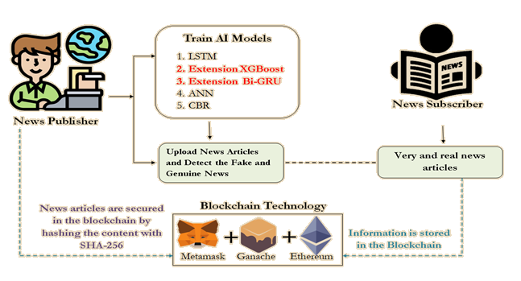

**Fig.5.1.1 System architecture**

**DATA FLOW DIAGRAM:**

A Data Flow Diagram (DFD) is a graphical representation that illustrates how data moves through a system. It depicts the flow of information between processes, data stores, and external entities, providing a clear understanding of the system's operations. In this scenario, DFDs are essential for visualizing how data related to news articles is processed, stored, and retrieved within the blockchain and AI framework. By breaking down the system into manageable Components, DFDs help identify the flow of information and the interactions between different elements, such as AI algorithms, user interfaces, and blockchain storage. This clarity enables stakeholders to see how data is transformed and manipulated throughout the process of detecting fake news. Moreover, DFDs facilitate the identification of potential bottlenecks or inefficiencies in data handling, promoting a more efficient design. Overall, employing DFDs can enhance communication among developers, stakeholders, and end-users, ensuring that the data management requirements are well understood and accurately implemented.

**Goals of Data Flow Diagram :**

1. DFDs help clarify the system requirements by providing a clear visual representation of data flows and processes involved.
2. By using DFDs, stakeholders can effectively communicate ideas and requirements, ensuring a common understanding of system functions.
3. DFDs assist in identifying all data sources, ensuring that all necessary information is captured for processing and analysis.
4. DFDs provide a clear visualization of how data moves through the system, making it easier to understand interactions between components.
5. DFDs aid in the design process by breaking down complex systems into manageable components, simplifying overall system architecture.
6. DFDs help identify redundant data flows or processes, leading to a more streamlined and efficient system design.
7. DFDs can serve as training tools for new users, enabling them to understand how data is handled within the system.

**Publisher**

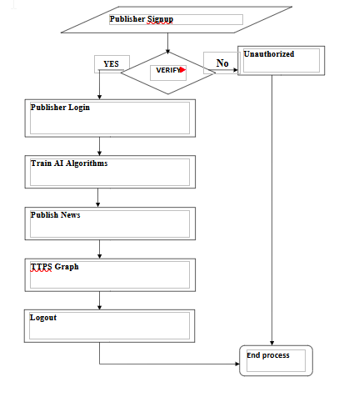**Fig.5.1.2 Data Flow Diagram - Publisher**

**Subscriber**

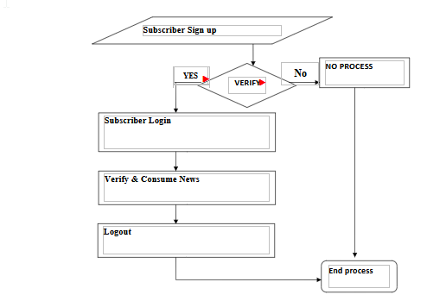

**Fig.5.1.3 Data Flow Diagram - Subscriber**

**5.2 UML DIAGRAMS**

Unified Modeling Language (UML) is a standardized modeling language used to visualize the design of a system. It provides a set of graphical notations to create abstract models of software systems, aiding in the documentation and understanding of complex architectures. In this scenario, UML diagrams can effectively illustrate the interactions between blockchain components, AI algorithms, and user interfaces. They help convey the overall structure and workflows, making it easier for stakeholders to comprehend the system's functionality. By representing classes, sequences, and states visually, UML enables clear communication among team members, ensuring that everyone has a shared understanding of the system's design. Furthermore, UML supports different perspectives, including structural and behavioral views, which can guide the implementation of blockchain and AI technologies for detecting fake news. This modeling approach also facilitates identifying potential issues early in development, leading to more efficient problem-solving and improved system quality.

**Advantages:**

* UML diagrams enhance communication among stakeholders by providing a clear visual representation of system components and their interactions.
* UML provides a standardized language, ensuring that all team members understand the diagrams regardless of their backgrounds or expertise.
* UML simplifies complex structures, making it easier to analyze and design intricate interactions between blockchain and AI technologies.
* UML diagrams serve as effective documentation tools, capturing system architecture and design decisions for future reference.
* By modeling before implementation, UML helps identify potential issues early, reducing development time and costs.

**Disadvantages**

* Designing comprehensive UML diagrams can be time-consuming and complex, requiring significant effort and expertise.
* Keeping UML diagrams updated with system changes can become burdensome, leading to outdated documentation if not managed properly.
* Team members unfamiliar with UML may face challenges in understanding and interpreting diagrams, potentially hindering collaboration.

**Use case diagram:**

A use case diagram illustrates the interactions between users and the system, showcasing functional requirements. It identifies key actors and their relationships with various use cases, enabling stakeholders to understand how users will engage with the system for news verification and fake news detection.

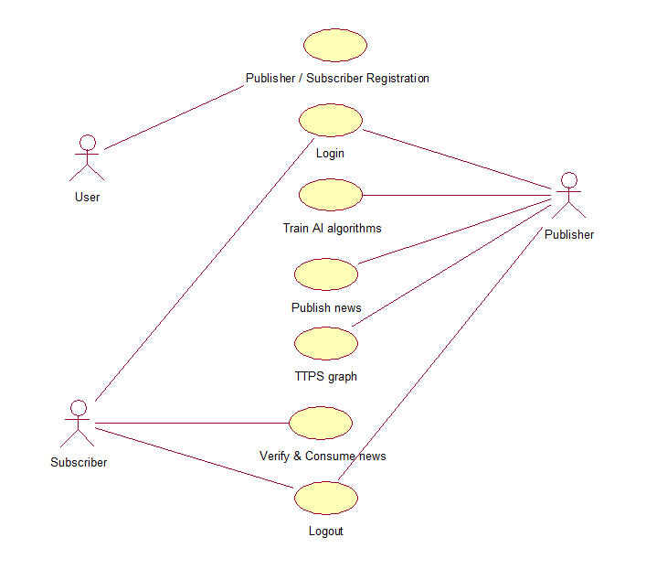

**Fig.5.2.1 Use Case Diagram**

**Class diagram:**

A class diagram provides a static view of the system's structure by depicting classes, their attributes, and relationships. It serves as a blueprint for the system’s architecture, enabling clear organization of data entities, supporting the development of algorithms for news verification and AI-driven fake news detection.

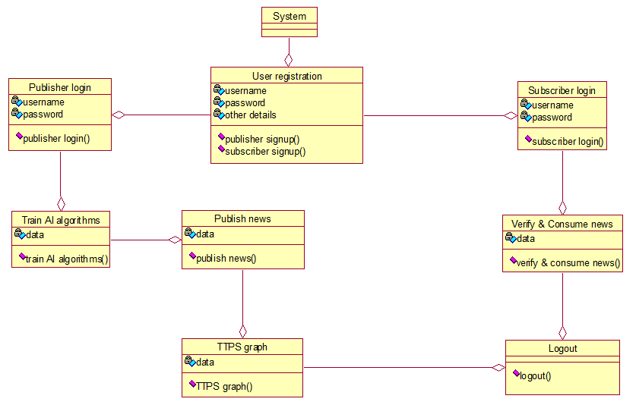

**Fig.5.2.2 Class diagram**

**Activity diagram:**

An activity diagram visualizes the dynamic aspects of the system by illustrating workflows and processes. It helps map the sequence of activities involved in data processing, from news article submission to verification and detection, allowing for efficient identification of potential bottlenecks or inefficiencies.

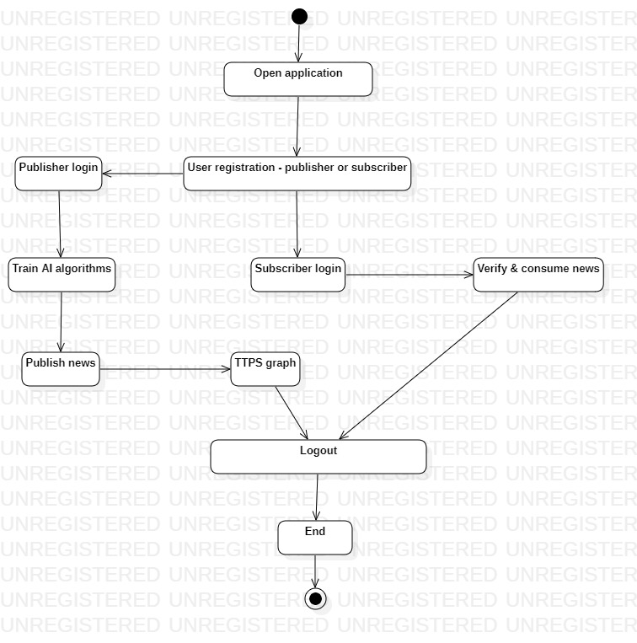

**Fig.5.2.3 Activity diagram**

**Sequence diagram:**

A sequence diagram details how objects interact over time, emphasizing the order of messages exchanged. It illustrates the flow of information during specific use cases, enhancing understanding of the interactions between users, AI algorithms, and blockchain components during the fake news detection process.

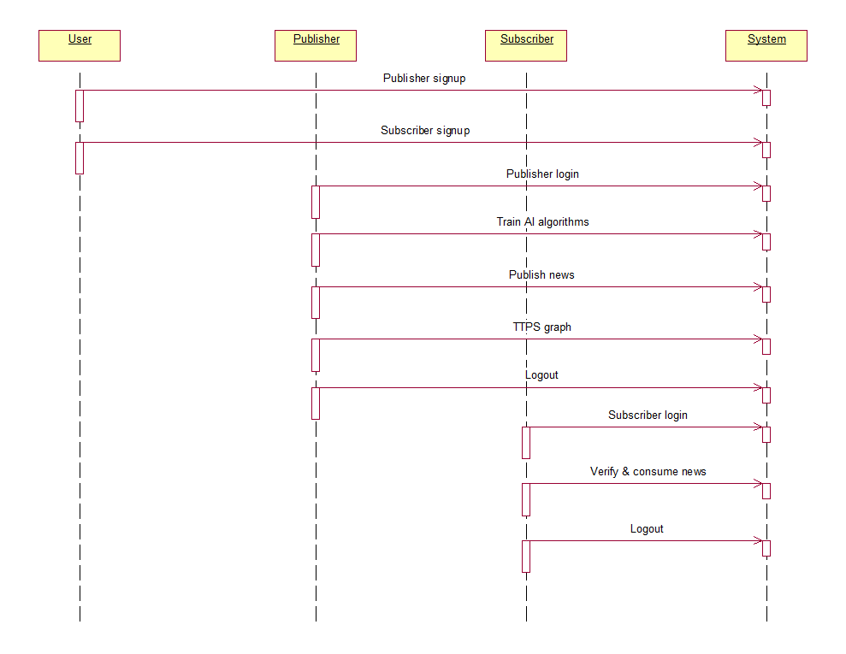

**Fig.5.2.4 Sequence diagram**

**Collaboration diagram:**

A collaboration diagram emphasizes the relationships and interactions among components in the system. It showcases how different entities work together to fulfill use cases, providing insights into the overall system architecture and enhancing clarity in the design of data handling and processing.

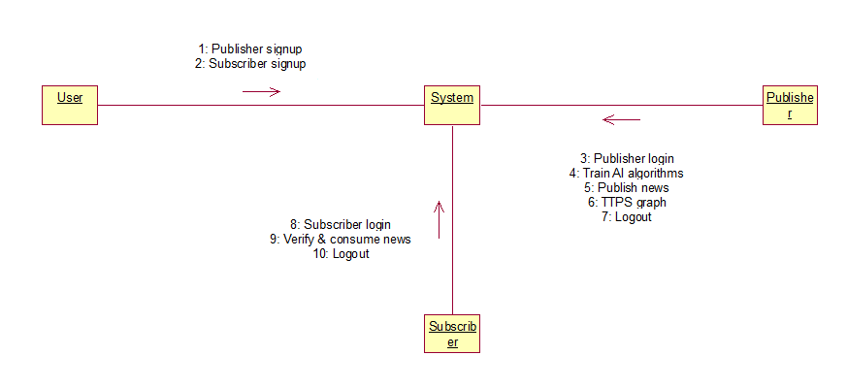

**Fig.5.2.5 Collaboration diagram**

**Component diagram:**

A component diagram represents the physical components of the system and their dependencies. It outlines how various modules, such as AI algorithms and blockchain storage, interact, facilitating the identification of modular structures and aiding in the planning of integration and deployment strategies.

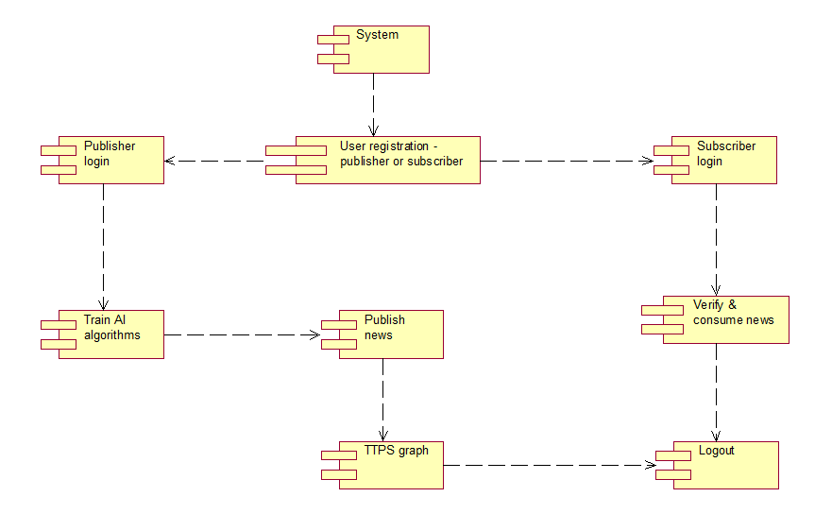

**Fig.5.2.6 Component diagram**

**Deployment diagram:**

A deployment diagram visualizes the physical deployment of the system components across hardware nodes. It illustrates how software artifacts are distributed across servers, ensuring that blockchain and AI functionalities are effectively implemented, while also highlighting considerations for scalability and reliability in the infrastructure.

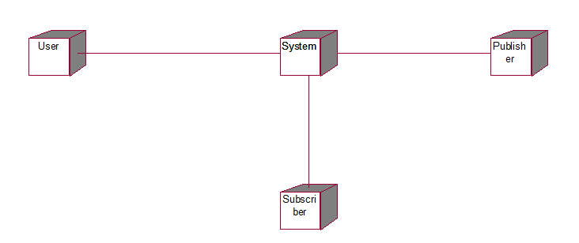**Fig.5.2.7 Deployment diagram**

**CHAPTER 6.IMPLEMENTATION**

**6.1 MODULES**

**1. New User Sign up**:

* **Publisher**: In this module, new users can register as publishers by providing necessary details. Once signed up, they are allowed to publish news articles and access features related to news management.
* **Subscriber**: This section enables users to register as subscribers, granting them access to view news articles published by others on the Blockchain.

**2. Publisher Login**:

* **Train AI Algorithm**: After logging in, publishers can train various AI algorithms (such as ANN, LSTM, Bi-directional GRU, and XGBOOST) on their dataset to improve the accuracy of fake news detection. The system displays performance metrics like accuracy, precision, recall, and F-score for each algorithm.
* **Publish News**: Publishers can write and submit news articles to the system. The AI will predict whether the news is real or fake before it is saved on the Blockchain, ensuring that only verified content is published.
* **TTPS Graph**: This feature allows publishers to view a graph representing Total Transactions Per Second (TTPS), showing the performance of the Blockchain in processing news transactions over time.

**3. Subscriber Login**:

* Verify and Consume News: Subscribers can log in to access the news articles stored on the Blockchain. They can view news content along with its SHA256 hash fingerprint, upload date, and the AI's prediction of the news articles
* being either fake or real. This module ensures that subscribers can easily verify the authenticity of the news they consume.

**6.2 SAMPLE CODE:**

from django.shortcuts import render

from django.template import RequestContext

from django.contrib import messages

from django.http import HttpResponse

from datetime import date

import json

from web3 import Web3, HTTPProvider

from datetime import datetime

import os

import matplotlib.pyplot as plt

import io

import base64

import numpy as np

import pandas as pd

from string import punctuation

from nltk.corpus import stopwords

import nltk

from nltk.stem import WordNetLemmatizer

import pickle

from nltk.stem import PorterStemmer

import os

from sklearn.preprocessing import StandardScaler

from sklearn.model_selection import train_test_split

from sklearn.feature_extraction.text import TfidfVectorizer #loading tfidf vector

from sklearn.metrics import accuracy_score

from sklearn.metrics import f1_score

from sklearn.metrics import precision_score

from sklearn.metrics import recall_score

import matplotlib.pyplot as plt

from sklearn import svm

import hashlib

from tensorflow.keras.utils import to_categorical

from tensorflow.keras.layers import Dense, Dropout, Activation, Flatten

from tensorflow.keras.models import Sequential, load_model, Model

import pickle

from tensorflow.keras.callbacks import ModelCheckpoint

from xgboost import XGBClassifier

from tensorflow.keras.layers import LSTM, GRU

from tensorflow.keras.layers import Bidirectional

import timeit

global username

global contract, web3

global usersList, newsList

ttps = []

stop_words = set(stopwords.words('english'))

lemmatizer = WordNetLemmatizer()

ps = PorterStemmer()

accuracy = []

precision = []

recall = []

fscore = []

def calculateMetrics(algorithm, predict, y_test):

    a = accuracy_score(y_test,predict)*100

    p = precision_score(y_test, predict,average='macro') * 100

    r = recall_score(y_test, predict,average='macro') * 100

    f = f1_score(y_test, predict,average='macro') * 100

    accuracy.append(a)

    precision.append(p)

    recall.append(r)

    fscore.append(f)

#define function to clean text by removing stop words and other special symbols

def cleanText(doc):

    tokens = doc.split()

    table = str.maketrans('', '', punctuation)

    tokens = [w.translate(table) for w in tokens]

    tokens = [word for word in tokens if word.isalpha()]

    tokens = [w for w in tokens if not w in stop_words]

    tokens = [word for word in tokens if len(word) > 1]

    tokens = [ps.stem(token) for token in tokens]

    tokens = [lemmatizer.lemmatize(token) for token in tokens]

    tokens = ' '.join(tokens)

    return tokens

X = np.load("model/X.npy")

Y = np.load("model/Y.npy")

tfidf_vectorizer = TfidfVectorizer(stop_words=stop_words, use_idf=True, smooth_idf=False, norm=None, decode_error='replace', max_features=300)

X = tfidf_vectorizer.fit_transform(X).toarray()

sc = StandardScaler()

X = sc.fit_transform(X)

indices = np.arange(X.shape[0])

np.random.shuffle(indices)

X = X[indices]

Y = Y[indices]

X_train, X_test, y_train, y_test = train_test_split(X, Y, test_size=0.2) #split dataset into train and test

xgb = XGBClassifier()

xgb.fit(X[0:9000], Y[0:9000])

predict = xgb.predict(X_test)

calculateMetrics("XGBoost", predict, y_test)

y_train1 = to_categorical(y_train)

y_test1 = to_categorical(y_test)

#now train ANN model

ann_model = Sequential()

#adding ANN dense layer with 32 neurons to filter dataset 50 times

ann_model.add(Dense(4, input_shape=(X_train.shape[1],)))

ann_model.add(Activation('relu'))

#dropout layer to remove irrrelevant features from dataset

ann_model.add(Dropout(0.6))

ann_model.add(Dense(4))

ann_model.add(Activation('relu'))

ann_model.add(Dropout(0.6))

ann_model.add(Dense(units = y_train1.shape[1], activation = 'sigmoid'))

ann_model.compile(optimizer = 'adam', loss = 'categorical_crossentropy', metrics = ['accuracy'])

if os.path.exists("model/ann_weights.hdf5") == False:

    model_check_point = ModelCheckpoint(filepath='model/ann_weights.hdf5', verbose = 1, save_best_only = True)

    hist = ann_model.fit(X_train, y_train1, batch_size = 16, epochs = 20, validation_data=(X_test, y_test1), callbacks=[model_check_point], verbose=1)

    f = open('model/ann_history.pckl', 'wb')

    pickle.dump(hist.history, f)

    f.close()

else:

    ann_model.load_weights("model/ann_weights.hdf5"

predict = ann_model.predict(X_test)

predict = np.argmax(predict, axis=1)

y_tests = np.argmax(y_test1, axis=1)

calculateMetrics("ANN", predict, y_tests)

X_train1 = np.reshape(X_train, (X_train.shape[0], 30, 10))

X_test1 = np.reshape(X_test, (X_test.shape[0], 30, 10))

lstm_model = Sequential()#defining deep learning sequential object

#adding LSTM layer with 100 filters to filter given input X train data to select relevant features

lstm_model.add(LSTM(100,input_shape=(X_train1.shape[1], X_train1.shape[2])))

#adding dropout layer to remove irrelevant features

lstm_model.add(Dropout(0.5))

#adding another layer

lstm_model.add(Dense(100, activation='relu'))

#defining output layer for prediction

lstm_model.add(Dense(y_train1.shape[1], activation='softmax'))

#compile LSTM model

lstm_model.compile(loss='categorical_crossentropy', optimizer='adam', metrics=['accuracy'])

if os.path.exists("model/lstm_weights.hdf5") == False:

    model_check_point = ModelCheckpoint(filepath='model/lstm_weights.hdf5', verbose = 1, save_best_only = True)

  hist = lstm_model.fit(X_train1, y_train1, batch_size = 32, epochs = 20, validation_data=(X_test1, y_test1), callbacks=[model_check_point], verbose=1)

    f = open('model/lstm_history.pckl', 'wb')

    pickle.dump(hist.history, f)

    f.close()

else:

    lstm_model.load_weights("model/lstm_weights.hdf5")

predict = lstm_model.predict(X_test1)

predict = np.argmax(predict, axis=1)

y_tests = np.argmax(y_test1, axis=1)

calculateMetrics("LSTM", predict, y_tests)

bigru = Sequential()#defining deep learning sequential object

#adding bi-directional GRU layer with 32 filters to filter given input X train data to select relevant features

bigru.add(Bidirectional(GRU(32, input_shape=(X_train1.shape[1], X_train1.shape[2]), return_sequences=True)))

#adding dropout layer to remove irrelevant features

bigru.add(Dropout(0.2))

#adding another layer

bigru.add(Bidirectional(GRU(32)))

bigru.add(Dropout(0.2))

#defining output layer for prediction

bigru.add(Dense(y_train1.shape[1], activation='softmax'))

#compile BI-LSTM model

bigru.compile(loss='categorical_crossentropy', optimizer='adam', metrics=['accuracy'])

if os.path.exists("model/bilstm_weights.hdf5") == False:

    model_check_point = ModelCheckpoint(filepath='model/bilstm_weights.hdf5', verbose = 1, save_best_only = True)

    hist = bigru.fit(X_train1, y_train1, batch_size = 32, epochs = 20, validation_data=(X_test1, y_test1), callbacks=[model_check_point], verbose=1)

    f = open('model/bilstm_history.pckl', 'wb')

    pickle.dump(hist.history, f)

    f.close()

else:

    bigru = load_model("model/bilstm_weights.hdf5")

predict = bigru.predict(X_test1)

predict = np.argmax(predict, axis=1)

y_tests = np.argmax(y_test1, axis=1)

calculateMetrics("BIGRU", predict, y_tests)

#function to call contract

def getContract():

    global contract, web3

    blockchain_address = 'http://127.0.0.1:8545'

    web3 = Web3(HTTPProvider(blockchain_address))

web3.eth.defaultAccount = web3.eth.accounts[0]

    compiled_contract_path = 'FakeNews.json' #FakeNews contract file

    deployed_contract_address = '0xe34F6d616F777096aC7C7536eC67467c5209a21b' #contract address

    with open(compiled_contract_path) as file:

        contract_json = json.load(file)  # load contract info as JSON

        contract_abi = contract_json['abi']  # fetch contract's abi - necessary to call its functions

    file.close()

    contract = web3.eth.contract(address=deployed_contract_address, abi=contract_abi)

getContract()

def getUsersList():

    global usersList, contract

    usersList = []

    count = contract.functions.getUserCount().call()

    for i in range(0, count):

        user = contract.functions.getUsername(i).call()

        password = contract.functions.getPassword(i).call()

        email = contract.functions.getEmail(i).call()

        phone = contract.functions.getPhone(i).call()

        address = contract.functions.getAddress(i).call()

        utype = contract.functions.getUserType(i).call()

        usersList.append([user, password, phone, email, address, utype])

def getNewsList():

    global newsList, contract

    newsList = []

    count = contract.functions.getNewsCount().call()

    for i in range(0, count):

        aid = contract.functions.getArticleId(i).call()

        author = contract.functions.getAuthor(i).call()

        article = contract.functions.getArticle(i).call()

        upload_date = contract.functions.getDate(i).call()

        atype = contract.functions.getType(i).call()

        newsList.append([aid, author, article, upload_date, atype])

getUsersList()

getNewsList()

def graph(request):

    if request.method == 'GET':

        global ttps

        num = []

        for i in range(len(ttps)):

            num.append((i+1))

        plt.plot(num, ttps)

        plt.xlabel("Number of Transactions")

        plt.ylabel("Transaction Per Second (TTPS)")

  plt.title("TTPS Graph")

        buf = io.BytesIO()

        plt.savefig(buf, format='png', bbox_inches='tight')

        plt.close()

        img_b64 = base64.b64encode(buf.getvalue()).decode()

        context= {'data':'TTPS Graph', 'img': img_b64}

        return render(request, 'PublisherScreen.html', context)

def PublishNews(request):

    if request.method == 'GET':

        return render(request, 'PublishNews.html', {})

def PublishNewsAction(request):

    if request.method == 'POST':

        global username, tfidf_vectorizer, xgb, sc, newsList, ttps

        news = request.POST.get('t1', False)

        data = news.strip().lower()

        data = cleanText(data)

        temp = []

        temp.append(data)

        temp = tfidf_vectorizer.transform(temp).toarray()

        temp = sc.transform(temp)

        predict = xgb.predict(temp)[0]

        result = "Real"

        if predict == 0:

            result = "Fake"

        start = timeit.default_timer()

        hashcode = hashlib.sha256(news.encode()).hexdigest()

        dd = str(date.today())+","+hashcode

        article_id = len(newsList) + 1

        msg = contract.functions.createNews(str(article_id), username, news, dd, result).transact()

        tx_receipt = web3.eth.waitForTransactionReceipt(msg)

        end = timeit.default_timer()

        ttps.append((end - start))

        newsList.append([str(article_id), username, news, dd, result])

        context= {'data':'Article Added with fingerprint = '+hashcode+'<br/>AI Predicted News Type : '+result+'<br/>'+str(tx_receipt)}

        return render(request, 'PublishNews.html', context)

def ReadNews(request):

    if request.method == 'GET':

        global newsList

        output = '<table border=1 align=center>'

        output+='<tr><th><font size=3 color=black>Article ID</font></th>'

        output+='<th><font size=3 color=black>Author Name</font></th>'

        output+='<th><font size=3 color=black>Article</font></th>'

        output+='<th><font size=3 color=black>Fingerprint Hash</font></th>'

    output+='<th><font size=3 color=black>Upload Date</font></th>'

        output+='<th><font size=3 color=black>AI Detected News Type</font></th></tr>'

        for i in range(len(newsList)):

            plist = newsList[i]

            arr = plist[3].split(",")

            output+='<tr><td><font size=3 color=black>'+plist[0]+'</font></td>'

            output+='<td><font size=3 color=black>'+plist[1]+'</font></td>'

            output+='<td><font size=3 color=black>'+plist[2]+'</font></td>'

            output+='<td><font size=3 color=black>'+arr[1]+'</font></td>'

            output+='<td><font size=3 color=black>'+arr[0]+'</font></td>'

            output+='<td><font size=3 color=black>'+plist[4]+'</font></td></tr>'

        output+="</table><br/><br/><br/><br/><br/><br/>"

        context= {'data':output}

        return render(request, 'UserScreen.html', context)

def TrainAI(request):

    if request.method == 'GET':

        global precision, recall, fscore, accuracy

        algorithms = ['ANN', 'LSTM', 'Extension1 Bidirectional GRU', 'Extension2 XGBoost']

        output = '<table border=1 align=center>'

        output+='<tr><th><font size=3 color=black>Algorithm Name</font></th>'

        output+='<th><font size=3 color=black>Accuracy</font></th>'

        output+='<th><font size=3 color=black>Precision</font></th>'

        output+='<th><font size=3 color=black>Recall</font></th>'

        output+='<th><font size=3 color=black>FSCORE</font></th></tr>'

        for i in range(1, len(algorithms)):

            output+='<tr><td><font size="" color="black">'+algorithms[i-1]+'</td>'

            output+='<td><font size="" color="black">'+str(accuracy[i])+'</td>'

            output+='<td><font size="" color="black">'+str(precision[i])+'</td>'

            output+='<td><font size="" color="black">'+str(recall[i])+'</td>'

            output+='<td><font size="" color="black">'+str(fscore[i])+'</td></tr>'

        output+='<tr><td><font size="" color="black">'+algorithms[3]+'</td>'

        output+='<td><font size="" color="black">'+str(accuracy[0])+'</td>'

        output+='<td><font size="" color="black">'+str(precision[0])+'</td>'

        output+='<td><font size="" color="black">'+str(recall[0])+'</td>'

        output+='<td><font size="" color="black">'+str(fscore[0])+'</td></tr>'

        output+="</table><br/>"

        df = pd.DataFrame([['Extension2 XGBoost','Precision',precision[0]],['Extension2 XGBoost','Recall',recall[0]],['Extension2 XGBoost','F1 Score',fscore[0]],['Extension2 XGBoost','Accuracy',accuracy[0]],

                           ['ANN','Precision',precision[1]],['ANN','Recall',recall[1]],['ANN','F1 Score',fscore[1]],['ANN','Accuracy',accuracy[1]],

                           ['LSTM','Precision',precision[2]],['LSTM','Recall',recall[2]],['LSTM','F1 Score',fscore[2]],['LSTM','Accuracy',accuracy[2]],

 ['Extension1 Bidirectional GRU','Precision',precision[3]],['Extension1 Bidirectional GRU','Recall',recall[3]],['Extension1 Bidirectional GRU','F1 Score',fscore[3]],['Extension1 Bidirectional GRU','Accuracy',accuracy[3]],

                          ],columns=['Algorithms','Metrics','Value'])

        df.pivot_table(index="Algorithms", columns="Metrics", values="Value").plot(kind='bar', figsize=(8, 4))

        plt.title("All Algorithms Performance Graph")

        buf = io.BytesIO()

        plt.savefig(buf, format='png', bbox_inches='tight')

        plt.close()

        img_b64 = base64.b64encode(buf.getvalue()).decode()

        context= {'data':output, 'img': img_b64}

        return render(request, 'PublisherScreen.html', context)

def index(request):

    if request.method == 'GET':

        return render(request, 'index.html', {})

def UserLogin(request):

    if request.method == 'GET':

       return render(request, 'UserLogin.html', {})

def PublisherLogin(request):

    if request.method == 'GET':

       return render(request, 'PublisherLogin.html', {})

def Register(request):

    if request.method == 'GET':

       return render(request, 'Register.html', {})

def RegisterAction(request):

    if request.method == 'POST':

        global usersList, ttps

        username = request.POST.get('t1', False)

        password = request.POST.get('t2', False)

        phone = request.POST.get('t3', False)

        email = request.POST.get('t4', False)

        address = request.POST.get('t5', False)

        utype = request.POST.get('t6', False)

        count = contract.functions.getUserCount().call()

        status = "none"

        for i in range(0, count):

            user1 = contract.functions.getUsername(i).call()

            if username == user1:

                status = "exists"

                break

        if status == "none":

            start = timeit.default_timer()

  msg = contract.functions.createUser(username, email, password, phone, address, utype).transact()

            tx_receipt = web3.eth.waitForTransactionReceipt(msg)

            usersList.append([username, password, phone, email, address, utype])

            end = timeit.default_timer()

            ttps.append((end - start))

            context= {'data':'Signup Process Completed<br/>'+str(tx_receipt)}

            return render(request, 'Register.html', context)

        else:

            context= {'data':'Given username already exists'}

            return render(request, 'Register.html', context)

def UserLoginAction(request):

    if request.method == 'POST':

        global username, contract, usersList

        username = request.POST.get('t1', False)

        password = request.POST.get('t2', False)

        status = "UserLogin.html"

        output = 'Invalid login details'

        for i in range(len(usersList)):

            ulist = usersList[i]

            user1 = ulist[0]

            pass1 = ulist[1]

            if user1 == username and pass1 == password and ulist[5] == 'Subscriber':

                status = "UserScreen.html"

                output = 'Welcome '+username

                break

        context= {'data':output}

        return render(request, status, context)

def PublisherLoginAction(request):

    if request.method == 'POST':

        global username, contract, usersList

        username = request.POST.get('t1', False)

        password = request.POST.get('t2', False)

        status = "PublisherLogin.html"

        output = 'Invalid login details'

        for i in range(len(usersList)):

            ulist = usersList[i]

            user1 = ulist[0]

            pass1 = ulist[1]

            if user1 == username and pass1 == password and ulist[5] == 'Publisher':

                status = "PublisherScreen.html"

                output = 'Welcome '+username

                break

        context= {'data':output}

return render(request, status, context)

**CHAPTER 7. SOFTWARE ENVIRONMENT**

**What is Blockchain?**

Blockchain is a record-keeping technology designed to make it impossible to hack the system or forge the data stored on the blockchain, thereby making it secure and immutable. It's a type of distributed ledger technology (DLT), a digital record-keeping system for recording transactions and related data in multiple places at the same time.

Each computer in a blockchain network maintains a copy of the ledger where transactions are recorded to prevent a single point of failure. Also, all copies are updated and validated simultaneously.

**Key features of blockchain technology:**

Blockchain technology is built on a foundation of unique characteristics that differentiate it from traditional databases. The following are its most important and defining characteristics:

* **Decentralization:** Blockchain decentralization is one of the fundamental aspects of the technology. Unlike centralized databases where a central authority, such as a bank, controls and verifies transactions, blockchain operates on a distributed ledger. This means multiple transparent participants, known as nodes, maintain, verify and update the ledger. Each node is spread across a network and contains a copy of the whole blockchain.
* **Immutability and security:** Cryptographic algorithms are used in blockchain to provide strong security, recording transactions and making tampering nearly impossible. Information is stored in blocks that are linked together using cryptographic hashes. If someone tries to tamper or modify a block, it would require the alteration of every subsequent block, making tampering computationally infeasible. This inherent blockchain security feature ensures immutability of information and makes blockchain an ideal platform for storing sensitive data and conducting secure transactions.
* **Transparency and traceability:** The inherent transparency of blockchain technology ensures every network participant has access to identical information. For instance, every transaction becomes part of a public ledger, visible to all participants. This transparency ensures trust and network accountability, because any inconsistency can be promptly recognized and resolved. Additionally, the blockchain's capacity to track the origin and trajectory of assets facilitates audits and decreases the likelihood of fraudulent activities.
* **Smart contracts:** These contracts are automated agreements encoded in software that execute the stipulations of a contract automatically. Smart contract codes are stored on the blockchain and carry out their functions once predetermined conditions are met. These contracts eliminate the need for intermediaries, streamline transactions, save money and speed up close times. They're used in a range of diverse sectors, including supply chain management, insurance and finance.

**Advantages of Blockchain:**

Several key benefits to using blockchain, including the following:

* **Uncorruptible:** It's almost impossible to corrupt a blockchain because millions of computers share and continually reconcile the information. Blockchain also has no single point of failure.
* **Efficient:** Transactions are often more efficient than in non-DLT-based transactional systems, though public blockchains can sometimes suffer from slow speed and inefficiency.
* **Resilient:** Blockchain is resilient; if one node goes down, all the other nodes have a copy of the ledger.
* **Trustworthy:** It provides trust among participants on a network. Confirmed blocks are difficult to reverse, which means data is difficult to remove or change.
* **Cost-effective:** It can be cost-effective because it often reduces the expense associated with transactions by eliminating middlemen and third parties.

**Disadvantages of Blockchain:**

Blockchain also has the following potential drawbacks, risks and challenges:

* **Ownership:** Blockchain can raise questions about ownership and who's responsible when problems arise.
* **Infrastructure issues:** Questions also come up about whether organizations are capable of investing in the infrastructure needed to build, participate and maintain a blockchain-based network, or even willing to do so.
* **Data challenges:** Changing data in a blockchain typically takes a lot of work.
* **Private keys:** Users have to keep track of their private keys to avoid losing their money.
* **Storage:** The need for storage can grow to be very large over time, which risks the loss of nodes if the ledger becomes too large for users to download.
* **Vulnerabilities:** Blockchain is susceptible to 51% attacks, which is a specific attack designed to overwhelm other participants in the network and change blocks.

**What is Python?**

Python is an interpreted, object-oriented, high-level programming language with dynamic semantics developed by Guido van Rossum. It was originally released in 1991. Designed to be easy as well as fun, the name "Python" is a nod to the British comedy group Monty Python. Python has a reputation as a beginner-friendly language, replacing Java as the most widely used introductory language because it handles much of the complexity for the user, allowing beginners to focus on fully grasping programming concepts rather than minute details.

Python is used for server-side web development, software development, mathematics, and system scripting, and is popular for Rapid Application Development and as a scripting or glue language to tie existing components because of its high-level, built-in data structures, dynamic typing, and dynamic binding. Program maintenance costs are reduced with Python due to the easily learned syntax and emphasis on readability. Additionally, Python's support of modules and packages facilitates modular programs and reuse of code. Python is an open source community language, so numerous independent programmers are continually building libraries and functionality for it.

**Python Use Cases**

1. Creating web applications on a server
2. Building workflows that can be used in conjunction with software
3. Connecting to database systems
4. Reading and modifying files
5. Performing complex mathematics
6. Processing [**big data**](https://www.teradata.com/Solutions/Big-Data)
7. Fast prototyping
8. Developing production-ready software

 Professionally, Python is great for backend web development, data analysis, [**artificial intelligence**](https://www.teradata.com/Solutions/Artificial-Intelligence), and scientific computing. Developers also use Python to build productivity tools, games, and desktop apps.

**Features and Benefits of Python**

* Compatible with a variety of platforms including Windows, Mac, Linux, Raspberry Pi, and others
* Uses a simple syntax comparable to the English language that lets developers use fewer lines than other programming languages
* Operates on an interpreter system that allows code to be executed immediately, fast-tracking prototyping
* Can be handled in a procedural, object-orientated, or functional way

**Python Syntax**

1. Somewhat similar to the English language, with a mathematical influence, Python is built for readability
2. Unlike other languages that use semicolons and/or parentheses to complete a command, Python uses new lines for the same function
3. Defines scope (i.e., loops, functions, classes) by relying indentation, using whitespace, rather than braces (aka curly brackets)

**Python Flexibility**

Python, a dynamically typed language, is especially flexible, eliminating hard rules for building features and offering more problem-solving flexibility with a variety of methods. It also allows uses to compile and run programs right up to a problematic area because it uses run-time type checking rather than compile-time checking.

**The Less Great Parts of Python**

On the down side, Python isn’t easy to maintain. One command can have multiple meanings depending on context because Python is a dynamically typed language. And, maintaining a Python app as it grows in size and complexity can be increasingly difficult, especially finding and fixing errors. Users will need experience to design code or write unit tests that make maintenance easier.   
Speed is another weakness in Python. Its flexibility, because it is dynamically typed, requires a significant amount of referencing to land on a correct definition, slowing performance. This can be mitigated by using alternative implementation of Python (e.g. PyPy).

**Python and AI**

AI researchers are fans of Python. Google TensorFlow, as well as other libraries (scikit-learn, Keras), establish a foundation for AI development because of the usability and flexibility it offers Python users. These libraries, and their availability, are critical because they enable developers to focus on growth and building.

**LIBRARIES/PACKAGES :-**

**Matplotlib**

This library is responsible for the plotting of numerical data. It is utilized in data analysis for this reason. An open-source library plots superior quality figures, for example, pie outlines, scatterplots, boxplots, and diagrams, in addition to other things.

**NumPy**

One of the most popular open-source Python packages, NumPy focuses on scientific and mathematical computation. It makes it easy to work with large matrices and multidimensional data thanks to built-in mathematical functions that make it easy to compute. It can be used as an N-dimensional container for all kinds of data, including linear algebra. An N-dimensional array with rows and columns is defined by the NumPy Array Python object. It can also be used as a random number generator because of this NumPy is preferred over lists in Python because it uses less memory, is faster, and is easier to use. Pictures, sound waves, and other parallel crude streams can be addressed as a multi-faceted exhibit of genuine qualities involving the NumPy interface for perception. NumPy is required for full-stack developers to use this machine learning library.

**Pandas**

Pandas is an open-source library authorized under the Berkeley Programming Conveyance (BSD). This well-known library is frequently utilized in the field of data science. They're generally utilized for examination, control, and cleaning of information, in addition to other things. Without having to switch to another programming language like R, Pandas enables us to carry out straightforward data modelling and analysis.

**SciPy**

Scipy is a Python library. Scientific computing, information processing, and high-level computing are the primary uses for this open-source library. The library contains a large number of easy-to-use methods and functions for quick and easy computation. Scipy can be utilized for numerical calculations close by NumPy.

Some of SciPy's subpackages include cluster, fftpack, constants, integrate, io, linalg, interpolate, ndimage, odr, optimize, signal, spatial, special, sparse, and stats.

**Scikit- learn**

Additionally, Scikit-learn is a Python-based open-source machine learning library. This library supports both supervised and unsupervised learning methods. This library already comes pre-installed with a number of well-known algorithms as well as the SciPy, NumPy, and Matplotlib packages. Spotify music recommendations are the Scikit-most-learn application that is most widely used.

**TensorFlow**

TensorFlow is a fast, open-source library for numerical calculations. It is utilized by ML and deep learning algorithms as well. It was developed by researchers in the Google Brain group of the Google AI organization and is now widely used by researchers in physics, mathematics, and machine learning for complex mathematical computations.

**Keras**

Keras is a Python-based open-source neural network library that enables in-depth research into deep neural networks. Keras emerges as a viable option as deep learning becomes more common because, according to its developers, it is an API (Application Programming Interface) designed for humans rather than machines. Keras has a higher rate of adoption in the research community and industry than TensorFlow or Theano. The TensorFlow backend engine should be downloaded first before Keras can be installed.

**CHAPTER 8. SYSTEM TESTING**

System testing is a form of software testing that assesses the overall behavior and efficiency of a software solution that is fully developed and integrated. It checks if the system conforms to the defined criteria and if it is ready to be deployed to the final users. System testing is usually performed by a professional testing team that is independent of the development team.

System testing is different from unit testing and integration testing, which are done at lower levels of the software development life cycle. Unit testing focuses on testing individual components or modules of the software, while integration testing focuses on testing the interactions and interfaces between the components or modules. System testing, on the other hand, focuses on testing the entire system as a whole, as well as its compatibility with the intended environment and other systems.

**8.1Different Kinds of System Testing in Software Testing**

There are many types of system testing, each with its own objectives, techniques, and tools. Some of the common types of system testing are:

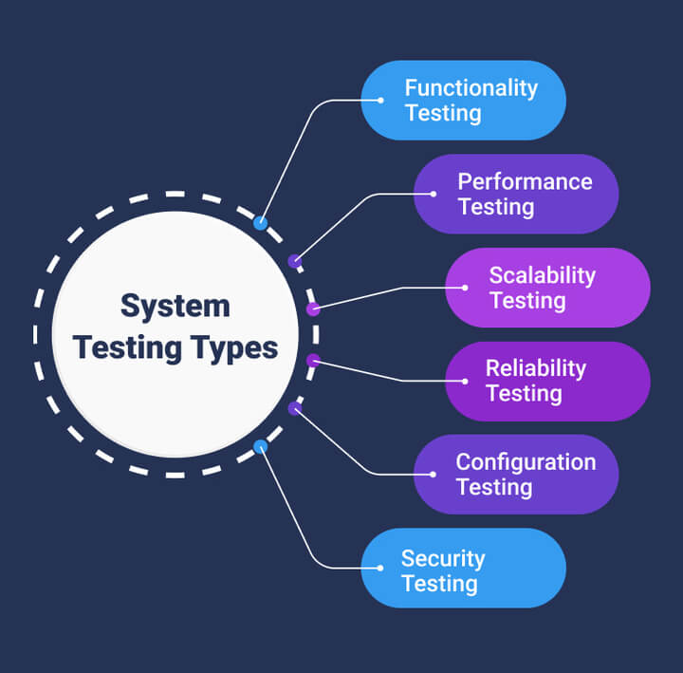

**Performance Testing**

Performance testing is done to measure the speed, scalability, stability, and reliability of the software product or application. Performance testing helps to determine how the software product or application responds to various levels of load, stress, and concurrency, and how it handles errors and failures. Performance testing also helps to identify and eliminate any performance bottlenecks or issues in the software product or application.

**Load Testing**

Load testing is a subset of performance testing that is done to determine the behavior of the system or software product under extreme load. Load testing helps to simulate the real-world scenarios and conditions that the software product or application will face when it is deployed and used by the end-users. Load testing also helps to determine the maximum capacity and throughput of the software product or application, and to ensure that it can handle the expected peak load without compromising the quality or performance.

**Security Testing**

Security testing is done to ensure that the software product or application is secure and safe from any unauthorized access, manipulation, or attack. Security testing helps to verify that the software product or application follows the best practices and standards of security, and that it protects the data and information of the users and the system. Security testing also helps to identify and fix any vulnerabilities or weaknesses in the software product or application that could compromise its security or integrity.

**Usability Testing**

Usability testing is done to ensure that the software product or application is user-friendly and easy to use. Usability testing helps to evaluate the user interface, navigation, design, and functionality of the software product or application from the perspective of the end-users. Usability testing also helps to collect feedback and suggestions from the users on how to improve the user experience and satisfaction of the software product or application.

**Compatibility Testing**

Compatibility testing is done to ensure that the software product or application is compatible with the intended environment and other systems. Compatibility testing helps to verify that the software product or application works well with different operating systems, browsers, devices, hardware, software, and networks. Compatibility testing also helps to ensure that the software product or application does not cause any conflicts or issues with other systems or software products.

**8.2 TEST CASES :**

|  |  |  |  |
| --- | --- | --- | --- |
| **S.NO** | **INPUT** | **If available** | **If not available** |
| 1 | Publisher | Publisher can login to system and then train AI algorithms for fake news detection, can publish and saved news in Blockchain and can view TTPS graph. | There is no process |
| 2 | Subscriber | Subscriber can login to system and then read all news stored by publisher from Blockchain | There is no process |

**CHAPTER 9. SCREENSHOTS**

To run project double click on ‘run.bat’ file to start web server and get below page

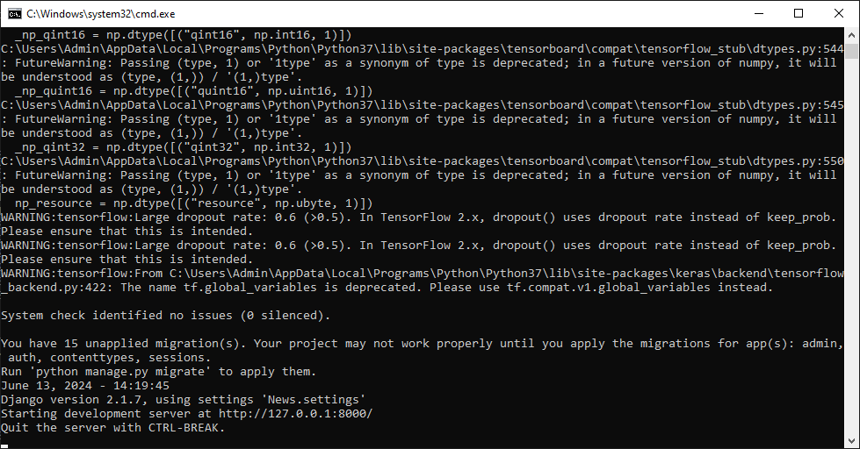

In above screen python web server started and now open browser and enter URL as <http://127.0.0.1:8000/index.html> and press enter key to get below page



In above screen click on ‘New User Sign Up Here’ link to get below page

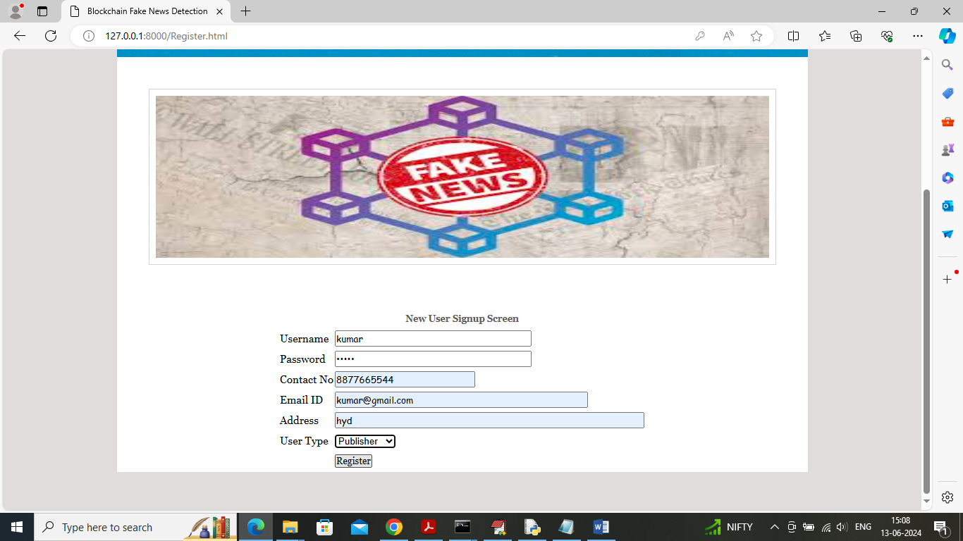

In above screen publisher is entering sign up details and then press button to saved details in Blockchain and then will get below output

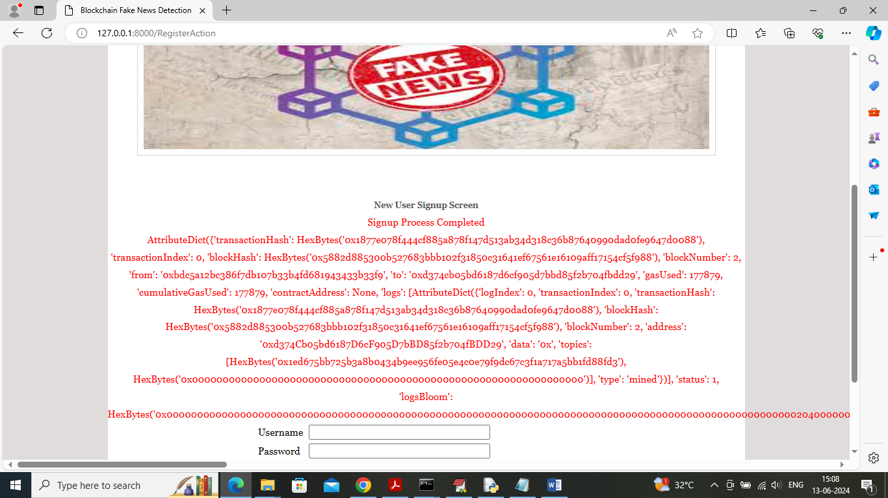

In above screen sign up completed and for you and your guide understanding purpose I am displaying all details log obtained from Blockchain after storage. In above log can see transaction number, block no, hash code and many other details and similarly add subscriber also

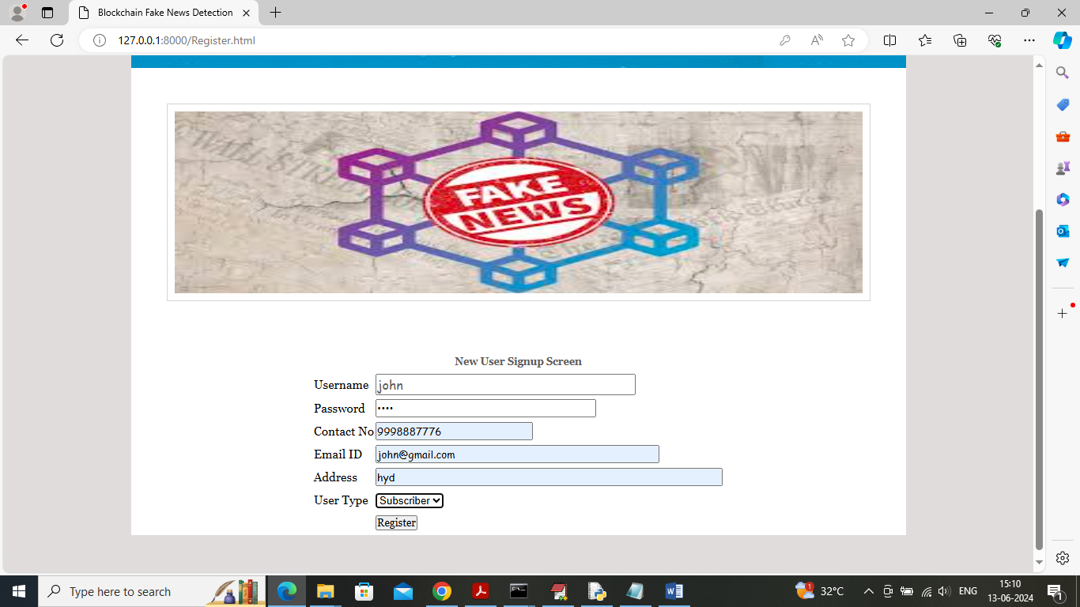

In above screen adding subscriber details and after pressing button will get below details

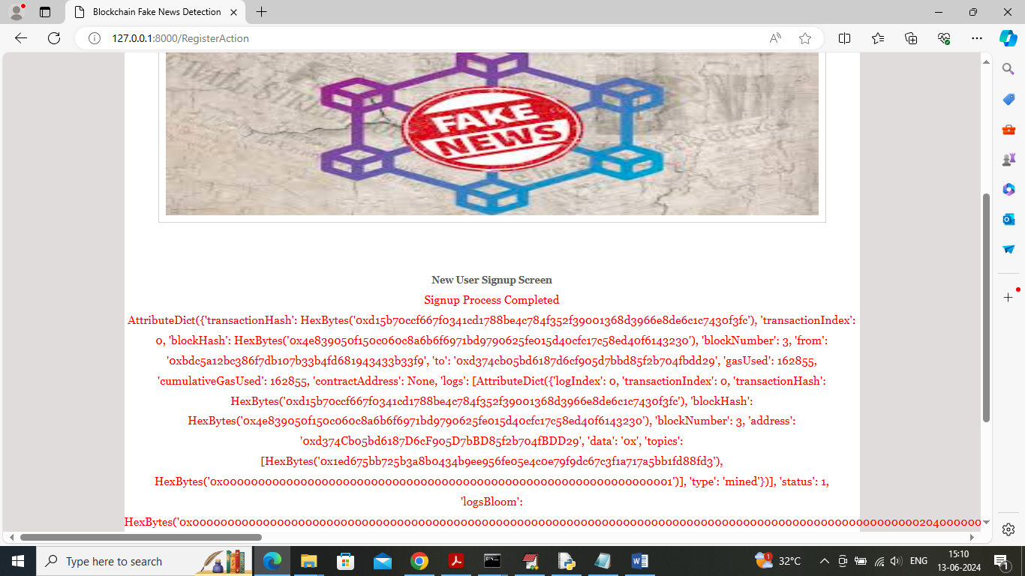

In above screen subscriber details also saved in Blockchain and now click on ‘Publisher Login’ link to get below login screen



In above screen publisher is login and after login will get below page



In above screen publisher can click on ‘Train AI Algorithms’ link to train algorithms and get below page

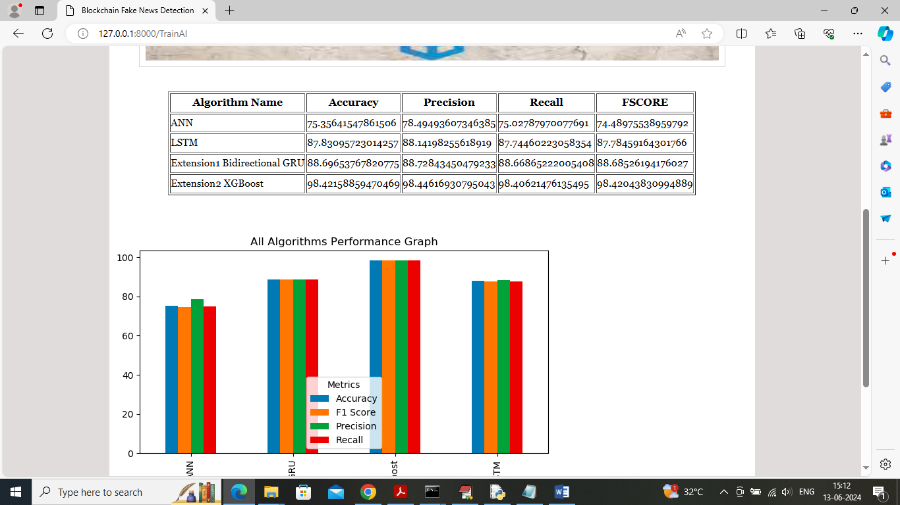

In above screen ANN and LSTM is the propose algorithm and then Bi-directional GRU and XGBOOST are the extension 1 and 2 algorithms and in above screen we can see extension algorithm got high accuracy. In above screen can see accuracy, precision, recall and FSCORE of each algorithm in tabular and graph format and now click on ‘Publish News’ link to get below page



In above screen publisher will write text (if you want you can take test news from Test News Folder) content and then AI will predict weather news is REAL or FAKE and then saved details in Blockchain and then will get below output

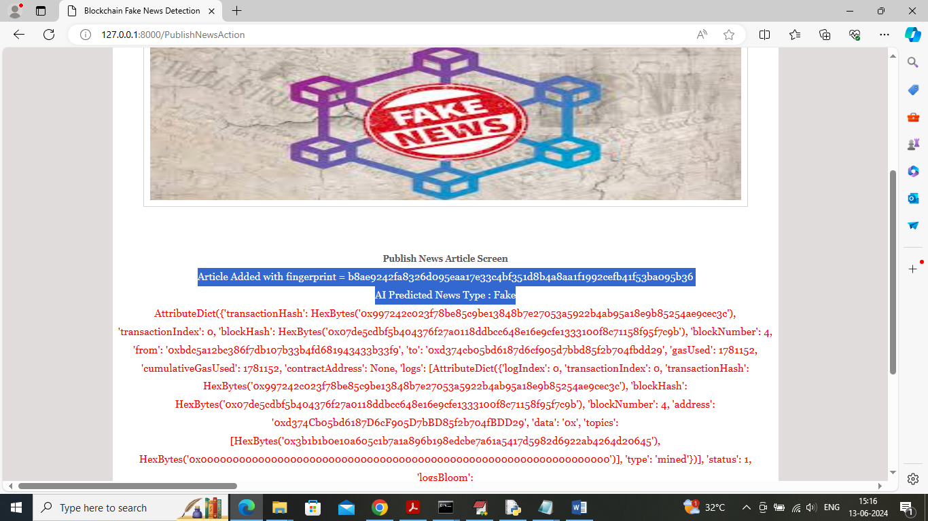

In above screen can see news article saved in Blockchain and in above screen in first two blue colour lines can see news article Finger print hash code and then can see AI prediction as Fake for given news and then can see all log details from Blockchain and similarly you can upload any number of news article to Blockchain and below is the another news content output

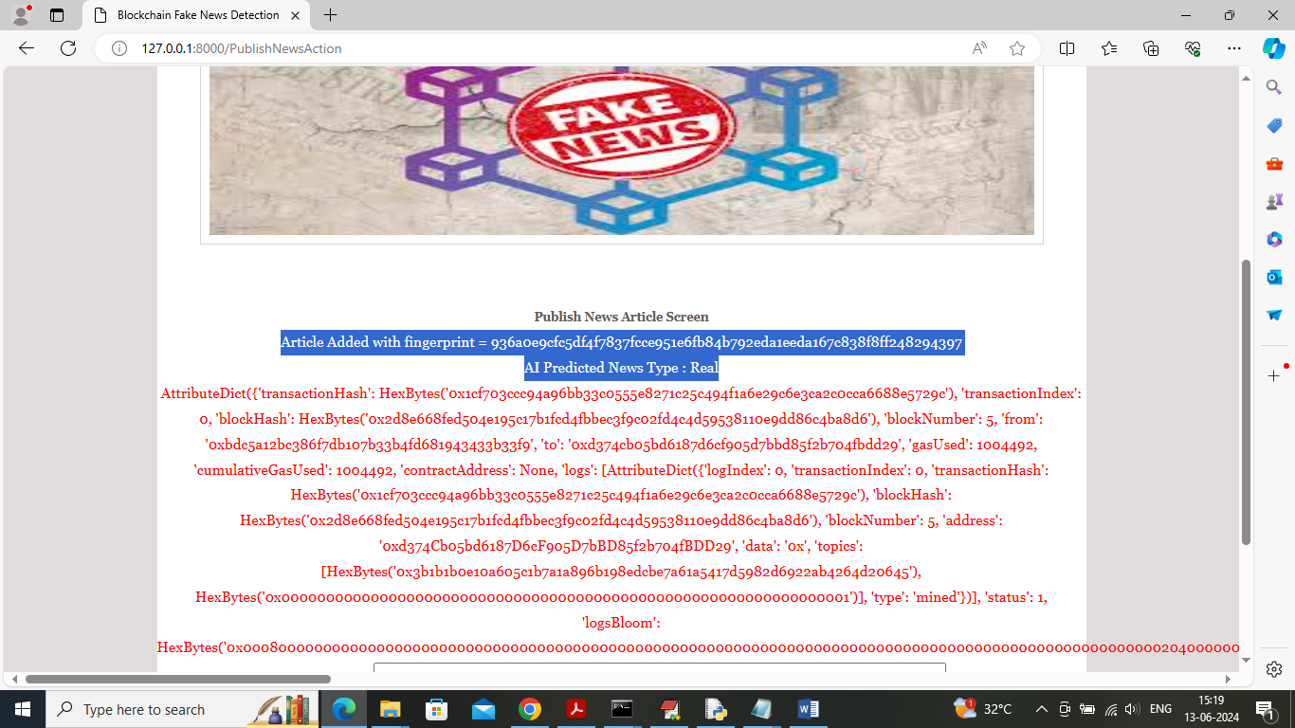

in above screen another news article is predicted as ‘Real’ and similarly you can upload any number of news and now click on ‘TTPS Graph’ link to get below graph

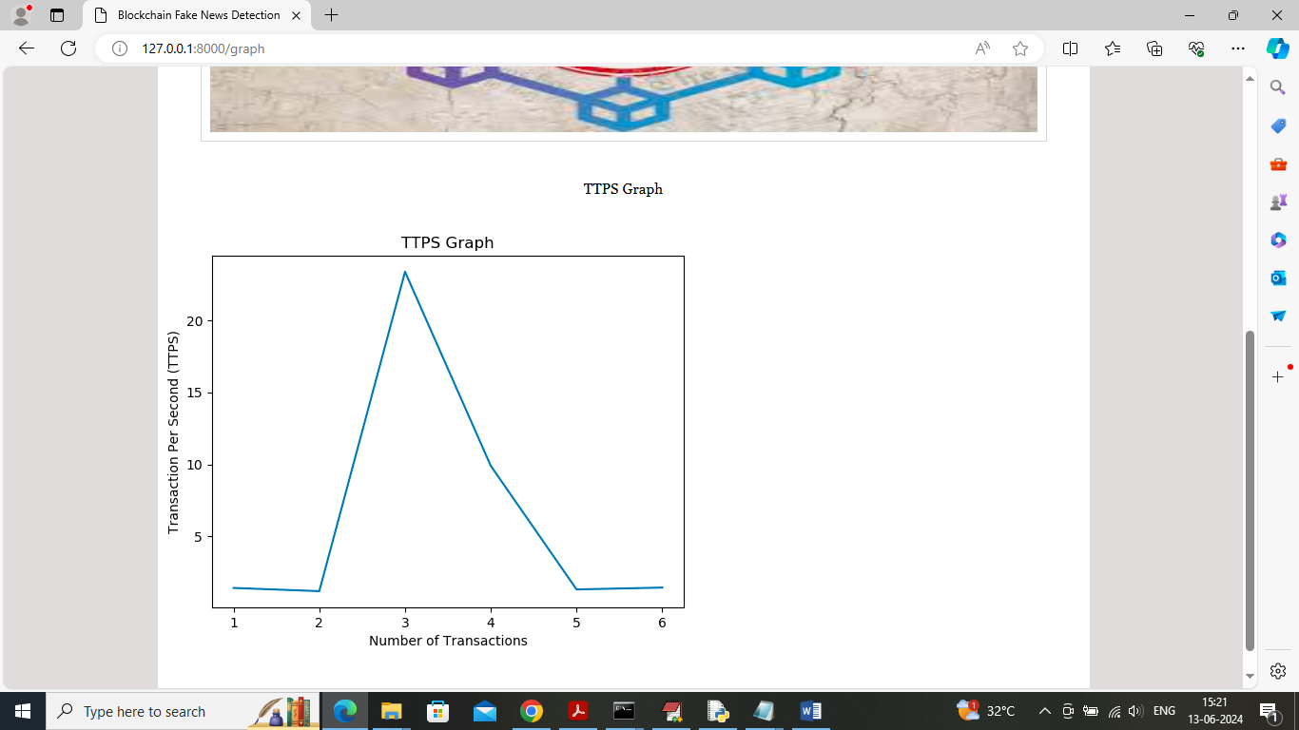

In above graph x-axis represents number of transaction processed and y-axis represents transaction time in seconds and now logout and login as ‘Subscribers’ to read news



In above screen subscriber is login and after login will get below page



In above screen subscriber can click on ‘Verify & Consume News’ link to view news from Blockchain

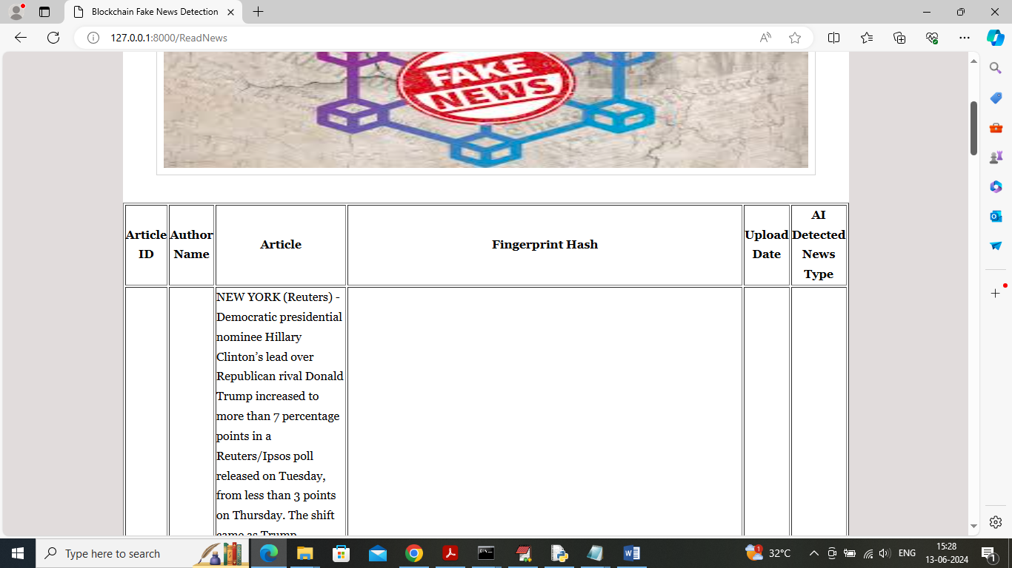

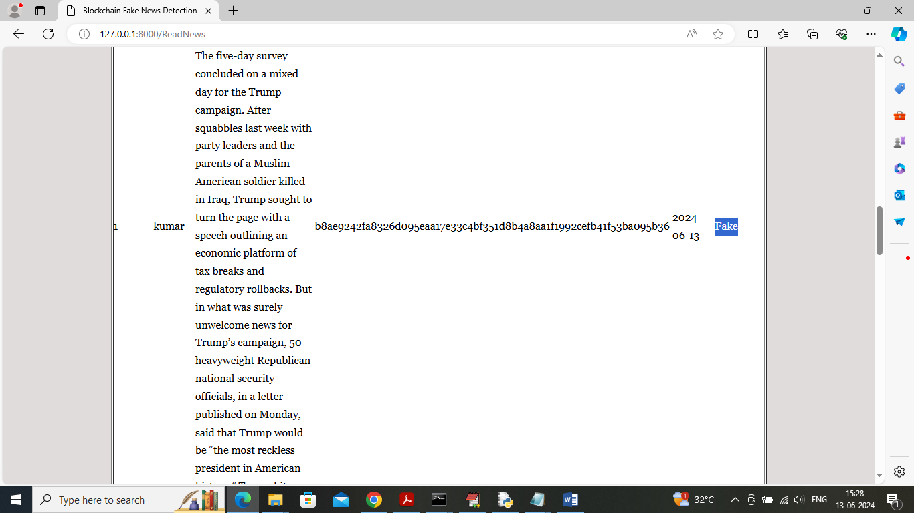

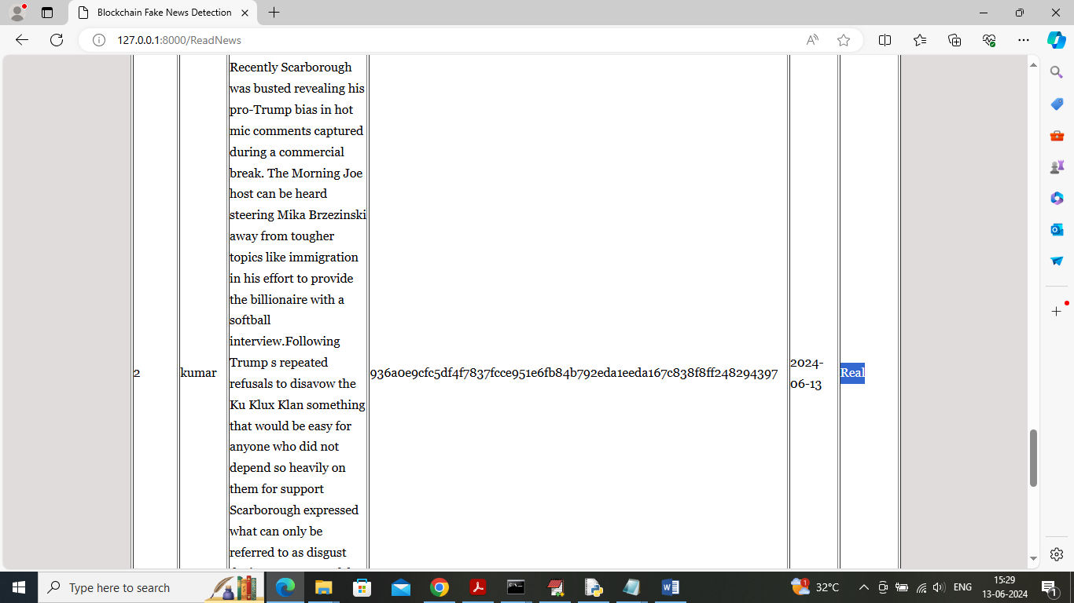

In above screens can see news content along with Hash code finger print and then can see uploaded date with AI predicted results as ‘Fake or Real’.

**CHAPTER 10. CONCLUSION**

The project presents an innovative framework that effectively combines Blockchain technology and Artificial Intelligence to address the pressing issue of fake news, enhancing the reliability of information dissemination. By utilizing Blockchain for secure storage and SHA256 hash codes for authenticity verification, the proposed system significantly improves the security and trustworthiness of news articles, ensuring users receive accurate information. The integration of advanced AI algorithms, including ANN, LSTM, and CBR, automates the detection and classification of fake news, leading to quicker identification of misinformation and reducing the burden on manual verification processes. Additionally, the project’s extension employs advanced techniques like Bi-directional GRU and XGBOOST, further enhancing detection accuracy and the system’s ability to analyze complex patterns in news content. Overall, the project sets the foundation for further enhancements, ensuring its adaptability in the continuously evolving landscape of misinformation and fake news while promoting ongoing research and development in the field.

**Future Scope:**

Future enhancements to the system could focus on several key areas to improve its effectiveness in combating fake news. First, expansion to multilingual support would enable the system to analyze and detect fake news across diverse linguistic and cultural contexts, broadening its applicability. Additionally, implementing a real-time monitoring and alert system would enhance its proactive nature, allowing users to stay informed about emerging misinformation trends. Developing collaborative platforms for news verification through partnerships with news organizations and fact-checking entities would leverage collective intelligence to improve accuracy and credibility. Lastly, focusing on user engagement and education initiatives can promote awareness of fake news and misinformation, equipping users with the tools to critically evaluate news content. Together, these advancements aim to create a more robust and informed society, effectively addressing the challenges posed by misinformation in today’s digital landscape.

**CHAPTER 11. REFERENCES**

[1] Ahuja, Nishtha, and Shailender Kumar. "S-HAN: Hierarchical Attention Networks with Stacked Gated Recurrent Unit for Fake News Detection." 2020 8th International Conference on Reliability, Infocom Technologies and Optimization (Trends and Future Directions) (ICRITO). IEEE, 2020.

[2] Ai, Songpu, et al. "Blockchain based Power Transaction Asynchronous Settlement System." 2020 IEEE 91st Vehicular Technology Conference (VTC2020-Spring). IEEE, 2020.

[3] Akshay et al., “Fake News Detection,” IEEE International Students' Conference on Electrical, Electronics and Computer Sciences, 2018.

[4] Antoun, Wissam, et al. "State of the Art Models for Fake News Detection Tasks." 2020 IEEE International Conference on Informatics, IoT, and Enabling Technologies (ICIoT). IEEE, 2020.

[5] Arjun Mukherjee et al., “Spotting Fake Reviewer Groups in Consumer Reviews”, International World Wide Web Conference, PP. 191-200, 20112. Committee (IW3C2).

[6] Bhoir, Smita Vinit. "An Efficient FAKE NEWS DETECTOR." 2020 International Conference on Computer Communication and Informatics (ICCCI). IEEE, 2020

[7] Desai, Harsh, Murat Kantarcioglu, and Lalana Kagal. "A Hybrid Blockchain Architecture for Privacy-Enabled and Accountable Auctions." 2019 IEEE International Conference on Blockchain (Blockchain). IEEE, 2019.

[8] Fitwi, Alem, Yu Chen, and Sencun Zhu. "A lightweight blockchain-based privacy protection for smart surveillance at the edge." 2019 IEEE International Conference on Blockchain (Blockchain). IEEE, 2019.

[9] Hasavari, Shirin, and Yeong Tae Song. "A secure and scalable data source for emergency medical care using blockchain technology." 2019 IEEE 17th International Conference on Software Engineering Research, Management and Applications (SERA). IEEE, 2019.

[10] Hirlekar, Vaishali Vaibhav, and Arun Kumar. "Natural Language Processing based Online Fake News Detection Challenges–A Detailed Review." 2020 5th International Conference on Communication and Electronics Systems (ICCES). IEEE, 2020.

[11] Kai Shu et al., “Understanding User Profiles on Social Media for Fake News Detection”, 2018 IEEE Conference on Multimedia Information Processing and Retrieval, PP. 430-435, 2018.

[12] Kang, Seong Ku, Junyoung Hwang, and Hwanjo Yu. "Multi-Modal Component Embedding for Fake News Detection." 2020 14th International Conference on Ubiquitous Information Management and Communication (IMCOM). IEEE, 2020.

[13] Kareem, Irfan, and Shahid Mahmood Awan. "Pakistani Media Fake News Classification using Machine Learning Classifiers." 2019 International Conference on Innovative Computing (ICIC). IEEE, 2019.

[14] Latifi, Sobhan, Yunpeng Zhang, and Liang-Chieh Cheng. "Blockchain-Based Real Estate Market: One Method for Applying Blockchain Technology in Commercial Real Estate Market." 2019 IEEE International Conference on Blockchain (Blockchain). IEEE, 2019.

[15] Li, Suisheng, et al. "Blockchain Dividing Based on Node Community Clustering in Intelligent Manufacturing CPS." 2019 IEEE International Conference on Blockchain (Blockchain). IEEE, 2019.